From neurocognitive phenotyping to prediction in cardiac rehabilitation patients: an explainable machine learning approach

Abstract
Background: Neurocognitive impairment is a frequent complication of Acute Coronary Syndrome (ACS). Current research often treats cognitive decline as a monolithic outcome, failing to account for the heterogeneous ways in which psychosocial and clinical factors interact to form distinct patient profiles.
Objective: This study sought to organize neurocognitive phenotypes in post-ACS patients using a data-driven approach and to identify the primary psychosocial and clinical predictors of severe impairment.
Methods: A two-stage machine learning pipeline was implemented in a cohort of ACS patients. In the first stage (unsupervised phase), K-means clustering was used to discover latent neurocognitive phenotypes. In the second stage (supervised phase), a benchmark of seven machine learning algorithms was used to predict cluster membership and identify key predictors. Model interpretability was achieved through Partial Dependence Plots (PDP) and probability heat maps.
Results: Two distinct phenotypes were identified: a "mild/moderate" cluster (n=231) and a "severe impairment" cluster (n=100). The XGBoost model demonstrated superior predictive performance (AUC = .959, Sensitivity = 99.1%, Kappa = .713). Across 6 of the 7 models, Social Support emerged as the most critical predictor. PDP analysis revealed a non-linear "staircase" effect, where neurocognitive risk remained high until a social support threshold of 35–38 points was reached. A significant "buffering effect" was observed, wherein high social support neutralized the negative impact of depressive symptoms on cognitive status.
Conclusion: Neurocognitive recovery after ACS is defined by a complex, non-linear interplay between affective burden and social resources. The consistent prioritization of social support across diverse algorithmic architectures suggests it is a primary structural determinant of resilience. Clinical triage should prioritize patients falling below the identified social support threshold to mitigate the risk of severe neurocognitive decline.

Keywords: Acute Coronary Syndrome; Neurocognition; Machine Learning; Social Support; Depression; Phenotyping; XGBoost.

Introduction
Acute Coronary Syndrome (ACS) remains a global health priority, not only due to its high cardiovascular mortality but also because of its profound secondary impact on brain health. Significant improvements in the immediate management of ACS have increased survival rates, yet long-term recovery is frequently compromised by neurocognitive dysfunction—a complication that remains largely under-screened in clinical practice (Pottle, 2020; Mirza et al., 2025).
The prevalence of cognitive impairment post-ACS is notably high but varies significantly across studies due to differences in screening tools and assessment timing. Systematic reviews and hospital-based studies report prevalence rates ranging from approximately 10% to 67%, with some estimates reaching as high as 85% in older cohorts (Zhao et al., 2019; Silva et al., 2018). These deficits are not limited to a single domain but encompass a broad spectrum of neurocognitive functions. The most frequently affected areas include memory deficits in verbal and visual domains are common, impacting the patient’s ability to recall medical instructions and to follow secondary prevention protocols (Zhao et al., 2019), reduction in verbal fluency have been documented as early indicators of cognitive decline following an ischemic event (Eggermont et al., 2012; Selmes et al., 2009; Silva et al., 2018). Significant difficulties in complex processing, cognitive flexibility, and maintaining focus are also reported (Mirza et al., 2025).
These neurocognitive manifestations have significant prognostic implications. Cognitive dysfunction has been identified as an independent predictor of excess mortality and is significantly associated with a higher risk of unplanned hospital readmissions (Ishihara et al., 2022). Furthermore, deficits in attention and memory act as major barriers to medication adherence and the lifestyle modifications required for effective cardiac rehabilitation (Pottle, 2020).
The mechanisms linking ACS to neurocognitive dysfunction are multifaceted, involving both structural and functional brain alterations. Pathophysiological drivers include cerebral hypoperfusion, the severity of atherosclerotic disease, and the impact of acute ischemia. Furthermore, systemic inflammation plays a critical role. These factors contribute to observed losses in grey matter volume in essential areas—such as the medial frontal cortex, cingulate, and parahippocampal gyri—as well as altered functional connectivity in middle-orbito-frontal regions (Peixoto, 2016).
Beyond the traditional clinical markers of Acute Coronary Syndrome (ACS), individual psychological architecture—specifically personality traits and coping mechanisms—plays a significant role in the neurocognitive manifestation. Personality traits, such as those defined by the Big Five or the Type D construct, are increasingly recognized as determinants of cognitive performance in cardiac patients. Traits like openness to experience are linked to cognitive flexibility, while higher scores in neuroticism or the social inhibition characteristic of Type D personality are associated with poorer performance in attention and executive function (Burkauskas et al., 2017). These traits may influence neurocognition either directly through neurobiological pathways or indirectly by modulating the patient's adherence to cardiac rehabilitation and their overall affective response to the ischemic event (Burkauskas et al., 2017).
In this context, the role of humor as a resilient coping mechanism and a facet of personality warrants attention. While often overlooked in standard cardiac assessments, humor can act as a psychological buffer, potentially mitigating the neurotoxic effects of systemic inflammation and stress-induced cortisol release that follow ACS (Moreira et al., 2025; Mirza et al., 2025). Positive personality attributes and adaptive coping strategies may protect against the "affect-cognitive syndrome" where depression and anxiety otherwise exacerbate cognitive decline (Apostolos et al., 2025).
Furthermore, the integrity of these psychosocial resources is closely intertwined with sleep quality. Poor sleep, a common complication post-ACS, has been identified as a significant factor increasing the susceptibility for cognitive impairment (Liu et al., 2024). Sleep disturbances can exacerbate maladaptive personality expressions and reduce the efficacy of humor as a coping strategy, creating a cycle of psychological distress and neurocognitive vulnerability. Disruptions in sleep architecture not only impair glympathic clearance and neuroplasticity but also lower the threshold at which psychological stressors impact objective cognitive functioning (Liu et al., 2024; Nutley et al., 2021). Therefore, understanding the neurocognitive phenotypes post-ACS requires an integrated perspective that accounts for the synergistic relationship between personality, adaptive coping, and the restorative role of sleep.
……..
Despite the growing body of evidence documenting these individual deficits, research remains fragmented. Current literature largely treats neurocognitive impairment as a monolithic or linear decline rather than a heterogeneous clinical manifestation. Consequently, there is a profound lack of evidence regarding the existence of distinct neurocognitive phenotypes within the ACS population. Most studies fail to organize these patients into structured profiles that account for the diverse ways in which cognitive, psychological, and social variables intersect to form unique patterns of impairment or resilience. The development of interventions in line with patients' risk factors and cognitive profiles may result in more personalized and efficient interventions (Mirza et al., 2025).
The data analysis followed a two-stage machine learning pipeline. In the first stage, K-means clustering, a robust unsupervised learning algorithm (James et al., 2021), was utilized to identify latent neurocognitive phenotypes without a priori group labels. In the second stage, a benchmark of seven supervised learning models—including XGBoost, Random Forest, SVM, MLP Neural Network, Decision Trees, Naive Bayes, and Logistic Regression—was implemented to validate the clinical stability of these clusters and identify their primary predictors (Ahlqvist et al., 2018; Bzdok et al., 2018).

Methods
Participants
331 patients, 274 (82.8%) males, with a mean age of 56.8 years (SD = 9.12; range [34–79]) and a mean of 10.12 years of education (SD = 3.87; range [2–23]). All participants experienced an Acute Coronary Syndrome (ACS) and are currently enrolled in a Phase III cardiac rehabilitation program at the Cardiac Rehabilitation Unit of the Department of Physical Medicine and Rehabilitation at Unidade Local de Saúde de São João. Patients with a history of neurological or psychiatric disorders, previous cardiac or cerebrovascular events, uncorrected sensory impairment, or illiteracy were excluded.

Psychological Assessment
The Addenbrooke’s Cognitive Examination-III (ACE-III) is a comprehensive screening tool used to evaluate neurocognitive functioning across five primary domains: Attention, Memory, Verbal Fluency, Language, and Visuospatial Functioning. The instrument shows high internal consistency (α= 0.914) and strong discriminative validity for identifying both mild and major cognitive impairment (Heish, Schubert, Hoon, Mioshi & Hodges, 2013; Machado, Baeta, Pimentel & Peixoto, 2015; Peixoto et al., 2018). Its clinical utility is well-established, including previous applications within cardiac pathology populations (Moreira, Peixoto, Sousa, Rocha & Peixoto, 2025; Peixoto et al, 2022; Silva et al., 2018).
Raw scores were converted into z-scores to account for demographic influences. This normalization followed the standard formula adjusted for the participants' age and education (Machado et al., 2015).
Based on the Five-Factor Model (Costa & McCrae, 1987), the Ten-Item Personality Inventory (TIPI) is a validated brief measure for assessing the "Big Five" personality domains (Brito-Costa et al., 2016). It is composed of 10 items rated on a 7-point Likert scale (1 = Strongly disagree to 7 = Strongly agree) covering five dimensions: Extraversion, Agreeableness, Conscientiousness, Emotional Stability, and Openness to Experience.
The Hospital Anxiety and Depression Scale (HADS) evaluate symptoms of anxiety and depression via 14 items, split equally between the two dimensions. Each item is rated on a four-point Likert scale ranging from 0 (“not present”) to 3 (“always present”). And each subscale ranges from 0 to 21. A cut-off of 8 is applied; scores of 0–7 are considered "normal," while scores ≥8 indicate clinically significant symptomatology (Pais-Ribeiro et al., 2007; Zigmond & Snaith, 1983).
The Pittsburgh Sleep Quality Index (PSQI) measures sleep quality and disturbances over a one-month period. It covers seven component scores and the scoring of each component ranges between 0–3. The Global PSQI score ranges from 0 to 21. A Global score > 5 indicates "poor" sleep quality and clinically relevant difficulties. (Carpenter & Andrykowski, 1998; João, Becker, Neves Jesus, & Martins, 2017).
The Social Support Satisfaction Scale (ESSS) (Pais-Ribeiro, 1999) evaluates an individual's satisfaction with their perceived social network and support systems. It covers four dimensions: satisfaction with Friends, intimacy, satisfaction with family, and Social Activities. It has 15 items on a 5-point Likert scale (1–5). Total scores range from 15 to 75; higher scores reflect greater perceived support.
Procedures
This study was approved by the Ethics Committee of ULS São João, EPE (CES_HSJ/FMUP_117-16), and all participants provided written informed consent. The sample consisted of individuals recruited at the time of their admission to the Physical and Rehabilitation Medicine service. The psychological assessment was conducted at the time of admission, in a single session.

Statistical Analysis and Predictive Modeling
Statistical analyses were performed using R (version 4.3.2). The methodology followed a two-stage machine learning pipeline: an exploratory unsupervised phase for phenotype discovery followed by a supervised predictive phase.
For the first phase, six cognitive domains derived from the ACE-III (Attention, Memory, Fluency, Language, Visuospatial, and the Total Score) were selected as clustering features. To prevent variables with larger scales from dominating the distance calculations, data were standardized using Z-score normalization. K-means clustering was implemented using the Euclidean distance metric. This algorithm partitioned the 331 participants into K groups by minimizing the within-cluster sum of squares (inertia). The selection of K was driven by the Average Silhouette Method. A Principal Component Analysis (PCA) was performed for dimensionality reduction. The clustering solution was projected onto the first two principal components to visually confirm the non-overlapping nature of the identified phenotypes.
In the second phase, a benchmark of seven supervised learning algorithms was implemented using a cross-validation framework to validate the clinical relevance of the cluster of higher neurocognitive severity and identify its predictors.
The model architectures are grouped into the following categories:
Linear/Probabilistic: Binary Logistic Regression and Naive Bayes were used to assess the conditional probability of cluster membership.
Tree-Based: Decision Trees (CART) provided an interpretable hierarchy. Random Forest (500 trees) and eXtreme Gradient Boosting (XGBoost) (100 rounds, η= 0.1) were utilized to handle high-dimensional interactions and non-linearities.
Kernel and Connectionist: Support Vector Machines (SVM) utilized a Radial Basis Function (RBF) kernel to project data into higher-dimensional space for optimal hyper-plane separation. A Multilayer Perceptron (MLP) Neural Network (5 hidden neurons) was trained to capture complex connectionist patterns.
The area under the ROC curve (AUC) was used to discriminate clusters. To ensure diagnostic balance and clinical utility, classification threshold was optimized using the Youden Index in the model with higher AUC, thus maximizing the sum of sensitivity and specificity. Model performance was further validated through a Confusion Matrix, yielding metrics for global accuracy, sensitivity, and specificity. Cohen’s Kappa was calculated to assess the level of agreement beyond chance. The mean decrease in Gini for tree models and the absolute beta weights for the logistic model, in order to determine feature importance.

Results
Table 1 details the results from neurocognitive and psychological assessments. Overall, the sample exhibits significant neurocognitive impairment across all evaluated domains when compared to normative data. The Total ACE-III mean z-score indicates a performance level substantially below the expected average for the participants' age and education. While all areas showed deficits, Verbal Fluency and Memory emerged as the most severely affected domains, whereas Language and Visuospatial functions remained relatively less impacted. Regarding the psychological profile, participants reported high levels of Extraversion and Emotional Stability. Affective symptoms, specifically anxiety and depression, both fell within the "normal" range of 0–7; however, the mean score for anxiety approached the clinical threshold of 8. Additionally, although the sample reported poor sleep quality—with mean values exceeding the cut-off of >5 on the PSQI—perceived social support remained high.

-------------- Table 1 HERE---------------

Neurocognitive phenotypes: Cluster characterization
The unsupervised K-means clustering partitioned the sample into two distinct neurocognitive phenotypes based on their ACE-III domain performance. This cluster solution was adopted due to a higher Silhouette mean (0,29) with two clusters in comparison to three clusters (0,24).
Cluster 1 (Mild/Moderate Phenotype; n = 231): Representing 69.8% of the sample, this group exhibited relatively preserved cognitive function, although scores remained slightly below normative means.
Cluster 2 (Severe Impairment Phenotype; n = 100): This phenotype, representing 30.2% of the participants, demonstrated significantly lower performance across all domains. The most pronounced deficits were observed in Memory (M = -3.76) and the ACE-III Total Score (M = -3.72), followed by Verbal Fluency (M = -3.05) and Attention (M = -2.51). Based on Cohen's d value, memory is the cognitive domain that contributes most to the separation of the two clusters. (Figure 1; Table 2).

--------Figure 1 HERE-------------
Cluster 2 (severe neurocognitive impairment phenotype) had a significantly higher proportion of female participants than expected by chance. This cluster also exhibited lower levels of Openness and higher levels of Depression and Anxiety. Beyond the neurocognitive variables, Depression was the most potent discriminator between clusters, yielding a medium effect size (Cohen's d = -0.53).

-------------- Table 2 HERE---------------
Comparative Performance of Predictive Models
The benchmark of seven supervised learning algorithms revealed a high degree of discriminative power in identifying the "severe impairment phenotype”. The models' performance varied based on their ability to capture non-linear clinical patterns. (Figure 3)
--------Figure 2 HERE-------------

-------------- Table 2 HERE---------------

The eXtreme Gradient Boosting (XGBoost) algorithm demonstrated superior discriminative power compared to other tested models, achieving an Area Under the Curve (AUC) of 0.959. This performance significantly outperformed other approaches, including the Support Vector Machine (SVM) (AUC = 0.837) and the Neural Network (AUC = 0.795) (Table 3). Traditional statistical methods, such as Logistic Regression, showed considerably lower discriminative power (AUC = 0.666), underscoring the necessity of non-linear machine learning architectures for capturing the complexity of neurocognitive phenotypes.
Further exploring the XGBoost, the Youden Index (J = 0.648) was used to determine the optimal classification threshold, the model yielded an overall accuracy of 89.0% (95% CI: 85.1% – 92.2%). The model exhibited exceptional sensitivity (99.1%), effectively identifying patients in the “mild/moderate phenotype” (Cluster 1), and a specificity of 65.7% in detecting the “severe phenotype” (Cluster 2). The Cohen’s Kappa of 0.713 further confirmed substantial agreement beyond chance.
In most of the evaluated models, the feature importance analysis revealed that social support was the most significant predictor of cluster membership (Figure 3). In the XGBoost model, social support was found to be 100% important, followed by stability and age.
--------Figure 3 HERE-------------
While social support did not show significant univariate differences between clusters in traditional mean-comparison tests, it emerged as the most critical predictor across six machine learning models suggesting a non-linear interaction effect. In order to explain the “black box” models, a partial dependence plot (PDP) was generated to isolate the effect of social support while keeping all other variables constant (Figure 4).
--------Figure 4 HERE-------------
Data extraction from the PDP revealed a threshold effect rather than a linear progression. Specifically, the probability of belonging to the severe phenotype remained stable at high-risk levels (≈ 0.71) for ESSS scores below 35. A significant inflection point was identified between scores 35 and 38, where the probability dropped by approximately 50%, eventually stabilizing at 0.25 for scores above 50.
A probability heat map was created to deepen the understating of the interaction between variables. The selection of variables for the heat map was empirically driven by the synthesis of predictive and comparative analyses. Social Support was selected as the primary axis due to its maximum relative importance (100%) in the XGBoost architecture, representing the most stable structural predictor. Depression was integrated as the interacting axis given its status as the non-cognitive variable with the largest clinical effect size (Cohen’s d = -0.53) for cluster differentiation.
The probability heat map revealed a critical nonlinear interaction between depressive load and social support (Figure 5). It was observed that the risk of belonging to Cluster 2 reaches its peak (probability > 0.70) only when high depression scores (HADS-D > 10) coincide with reduced levels of social support (ESSS < 35). Conversely, the map demonstrates a robust protective effect of social support: for individuals with high ESSS scores (> 55), the probability of severe neurocognitive decline remains low and stable, regardless of the severity of depressive symptoms.

Figure 5. Probability heat map of the interaction between social support and depression

Discussion
The present study utilized an explainable machine learning pipeline to organize and predict neurocognitive phenotypes following Acute Coronary Syndrome (ACS). Our findings confirm the existence of two distinct clusters: a "Preserved" phenotype (Cluster 1) and a "Severe Impairment" phenotype (Cluster 2). While the prevalence of cognitive impairment post-ACS is well-documented (Zhao et al., 2019; Silva et al., 2018), our data-driven approach uniquely identifies that this impairment is not a monolithic decline, but a specific affective-cognitive syndrome driven by the interplay between social resources and depressive burden.
Our analysis revealed that beyond objective neurocognitive scores, depression (HADS-D) was the most potent non-cognitive discriminator between phenotypes, yielding a medium effect size. This aligns with previous research suggesting that depressive symptoms are independent predictors of cognitive decline post-cardiac events (Oldham et al., 2021; Burkauskas et al., 2017).
A standout finding of this study is the consistent identification of Social Support as the most critical predictor of neurocognitive phenotype membership, emerging as the top-ranked variable in six of the seven evaluated models (XGBoost, Decision Tree, Logistic Regression, Naive Bayes, Random Forest, and SVM). This convergence across mathematically diverse architectures—ranging from linear probabilistic models to complex non-linear ensembles—suggests that the protective role of social resources is a robust structural feature of post-ACS recovery, rather than an artifact of a specific statistical method (Molnar et al., 2020).
While traditional cardiovascular research often treats psychosocial factors as secondary 'noise' or auxiliary variables (Albus et al., 2019), this algorithmic consensus elevates social support to a primary clinical determinant (Bzdok et al., 2018; Marquand et al., 2016).
The predictive superiority of the XGBoost algorithm over linear baseline models aligns with its specialized architecture designed to identify non-linear decision boundaries and threshold effects (Chen & Guestrin, 2016). Furthermore, the convergence of six different algorithmic architectures on Social Support as the primary determinant.
In addition, our XGBoost model adds a layer of complexity: while depression is a marker of severity, its impact is non-linear. The probability heat map demonstrates that high depressive load only translates into a high risk of severe neurocognitive impairment when social support is insufficient. This suggests that post-ACS cognitive dysfunction may be mediated by a "synergistic vulnerability" where affective distress and social isolation converge to impair neurovascular recovery (Mirza et al., 2025).
One of the most striking findings of this study is the "staircase" relationship between Social Support (ESSS) and neurocognitive risk. The Partial Dependence Plot (PDP) identified a critical inflection point at 35–38 points on the ESSS scale. Below this threshold, the risk of severe impairment remains high and stagnant, regardless of minor improvements in social satisfaction. This "threshold effect" challenges the linear assumptions of traditional statistical models (Moreira et al., 2025; Peixoto et al., 2022). Clinically, this implies that social support acts as a "neuroprotective switch"—once a certain level of social integration is achieved, the brain's resilience to the neurotoxic effects of systemic inflammation and post-infarct metabolic stress is significantly enhanced (Mirza et al., 2025).
The findings of this study provide a significant shift from traditional linear risk assessment toward a more nuanced, phenotypic understanding of neurocognitive recovery after ACS. By moving beyond isolated prevalence rates, which vary widely in the literature, our results offer a structured framework for personalized cardiac rehabilitation. The identification of a high-accuracy predictive threshold via the Youden Index offers a concrete tool for clinical decision-making. Unlike general screening tools that may yield high false-positive rates (Zhao et al., 2019), the XGBoost model’s exceptional sensitivity (99.1%) allows clinicians to effectively "rule out" cognitive risk in patients with high social support. A triage system where patients with Social Support (ESSS) scores < 35 and Depression (HADS-D) scores > 10 are immediately identified for intensive neuropsychological follow-up. This is critical because these patients fall into the "High Risk Zone" identified in our probability heat map, where the risk of belonging to the severe phenotype exceeds 70%. A "staircase" function in the relationship between social support and neurocognition is perhaps the most vital research implication. Traditional statistical models often assume that any incremental increase in social support provides an equal benefit (Peixoto et al., 2022). However, our Partial Dependence Plot analysis demonstrates a threshold effect: cognitive risk remains stagnant and critical until an ESSS score of approximately 35–38 is reached.
Our results provide empirical support for the Stress-Buffering Hypothesis (Cohen & Wills, 1985) which posits that social resources provide a protection against the deleterious effects of psychological distress. The probability heat map proves that high social support acts as a "buffer" that neutralizes the neurotoxic impact of depression (Albus et al., 2019; Apostolos et al., 2025). Even in patients with clinically significant depressive loads, high social integration (> 55 points) maintains a low probability of severe neurocognitive decline. This reinforces that cardiac rehabilitation should not only focus on physical exercise and pharmacological adherence but must also prioritize the restoration of social networks. Social support should be treated as a "modifiable biological factor" that directly influences neurovascular health post-ACS.
Finally, the massive performance gap between the XGBoost and Logistic Regression proves that the interplay between psychosocial variables and neurocognition is too complex for traditional inferential statistics. Future studies should integrate explainable artificial intelligence into routine cardiac practice. Using tools like PDPs and Heat Maps allows the clinician to transform the "black box" of machine learning into an actionable clinical roadmap.
While this study offers a novel, data-driven perspective on post-ACS neurocognitive phenotypes, several limitations must be acknowledged. The study cohort was predominantly male, which may limit the generalizability of our predictive model to female patients, who may present with different psychosocial risk profiles. Furthermore, the strict exclusion criteria—omitting individuals with previous neurological disorders, illiteracy, or history of stroke—means that our findings represent a "primary" neurocognitive decline directly related to the cardiac event, rather than the more complex, comorbid decline often seen in clinical practice.
The cross-sectional nature of the study identifies associations and predictive patterns but cannot definitively establish a causal relationship between psychosocial factors and neurocognitive decline.
Despite these limitations, the robustness of the algorithmic consensus—where diverse models converged on social support as the primary predictor—provides a strong foundation for clinical application. These findings suggest that the next generation of cardiac rehabilitation protocols must move beyond a 'one-size-fits-all' approach and utilize explainable machine learning to identify patients who lack the social buffering required for neurocognitive resilience.
FUNDING: None
COMPETING INTERESTS: None

References
Albus, C., Waller, C., Fritzsche, K., Gunold, H., Haass, M., Hamann, B., ... & Herrmann-Lingen, C. (2019). Significance of psychosocial factors in cardiology: update 2018: Position paper of the German Cardiac Society. Clinical Research in Cardiology, 108(11), 1175-1196. 10.1007/s00392-019-01488-w
Ahlqvist, E., Storm, P., Käräjämäki, A., Martinell, M., Dorkhan, M., Carlsson, A., ... & Groop, L. (2018). Novel subgroups of adult-onset diabetes and their association with outcomes: a data-driven cluster analysis of six variables. The Lancet Diabetes & Endocrinology, 6(5), 361-369.
Apostolos, A., Konstantinou, K., Ktenopoulos, N., Vlachakis, P. K., Skalidis, I., Chrysostomidis, G., ... & Tsioufis, K. (2025). Depression and Coronary Artery Disease—Where We Stand?. Journal of Clinical Medicine, 14(12), 4281. https://doi.org/10.3390/jcm14124281
Bdzok, D., Altman, N. & Krzywinski, M.. (2018). Statistics versus machine learning. Nat Methods, 15(4), 233-234. doi:10.1038/nmeth.4642
Brito-Costa, S., Bem-haja, P., Moisao, A., Alberty, A., Castro, F., & Almeida, H. (2016). Pychometric properties of Portuguese version of big five inventory (bfi). International Journal of Developmental and Educational Psychology. Revista INFAD de Psicología., 1, 83. https://doi.org/10.17060/ijodaep.2015.n2.v1.325
Burkauskas, J., Brozaitiene, J., Bunevicius, A., Neverauskas, J., Zaliunaite, V., & Bunevicius, R. (2016). Association of depression, anxiety, and type D personality with cognitive function in patients with coronary artery disease. Cognitive and Behavioral Neurology, 29(2), 91-99. DOI: 10.1097/WNN.0000000000000093
Carpenter, J. S., & Andrykowski, M. A. (1998). Psychometric evaluation of the Pittsburgh sleep quality index. Journal of PsychosomaticRresearch, 45(1), 5-13.
Chen, T. & Guestrin, C. (2016). XGBoost: A Scalable Tree Boosting System. KDD '16: Proceedings of the 22nd ACM SIGKDD International Conference on Knowledge Discovery and Data Mining. https://doi.org/10.1145/2939672.2939785
Costa, P. T. J., & McCrae, R.R. (1987). Validation of the five-factor model across instruments and observers. Journal of Personality and Social Psychology, 52, 81-90. Doi 10.1037/00223514.52.1.81
Eggermont, L. H., De Boer, K., Muller, M., Jaschke, A. C., Kamp, O., & Scherder, E. J. (2012). Cardiac disease and cognitive impairment: a systematic review. Heart, 98(18), 1334-1340. https://doi.org/10.1136/heartjnl-2012-301682
Hsieh, S., Schubert, S., Hoon, C., Mioshi, E., & Hodges, J. R. (2013). Validation of the Addenbrooke's Cognitive Examination III in frontotemporal dementia and Alzheimer's disease. Dementia and geriatric cognitive disorders, 36(3-4), 242-250.
Ishihara, K., Izawa, K. P., Kitamura, M., Ogawa, M., Shimogai, T., Kanejima, Y., ... & Shimizu, I. (2022). Impact of mild cognitive impairment on unplanned readmission in patients with coronary artery disease. European Journal of Cardiovascular Nursing, 21(4), 348-355. https://doi.org/10.1093/eurjcn/zvab091
João, K. A. D. R., Becker, N. B., de Neves Jesus, S., & Martins, R. I. S. (2017). Validation of the Portuguese version of the Pittsburgh sleep quality index (PSQI-PT). Psychiatry Research, 247, 225-229. https://doi.org/10.1016/j.psychres.2016.11.042
Liu, M., Ma, J., Bao, K., Gu, Y., Zhao, J., Ren, D., ... & Xu, X. (2024). Sleep quality associate with the increased prevalence of cognitive impairment in coronary artery disease patients: A retrospective case–control study. Open Medicine, 19 (1), pp. 20241034. https://doi.org/10.1515/med-2024-1034
Machado, A., Baeta, É., Pimentel, P., & Peixoto, B. (2015). Psychometric and normative indicators of the portuguese version of the Addenbrooke's Cognitive Examination-III. preliminary study on a sample of healthy subjects. Acta Neuropsychologica, 13(2).
Marquand, A. F., Rezek, I., Buitelaar, J., & Beckmann, C. F. (2016). Understanding heterogeneity in clinical cohorts using normative models: beyond case-control studies. Biological psychiatry, 80(7), 552-561. https://doi.org/10.1016/j.biopsych.2015.12.023
Mirza, U. B., Mansoor, F., Fnu, U., Riaz, S., Zaka, M., Raza, A. A., & Samadi, A. (2025). Cognition and coronary events: A narrative overview of neurocognitive impairment in ACS patients. American Heart Journal Plus: Cardiology Research and Practice, 60 (2025), 100666. https://doi.org/10.1016/j.ahjo.2025.100666
Molnar, C. (2020). Interpretable machine learning: A guide for making black box models explainable. Leanpub.978-3911578035
Moreira, I., Peixoto, M., Sousa, D., Rocha, A., & Peixoto, B. (2025). Predictive model of neurocognitive functioning after acute coronary syndrome. A machine learning approach. Journal of Cardiovascular and Thoracic Research, 17(3), 181. https://pmc.ncbi.nlm.nih.gov/articles/PMC12620144/
Nutley, S. K., Read, M., Eichenbaum, J., Nosheny, R. L., Weiner, M. W., Mackin, R. S., & Chage, P. (2021). Poor sleep quality and daytime fatigue are associated with subjective but not objective cognitive functioning in clinically relevant hoarding. Biological Psychiatry Global Open Science, 2(4), 480-488. 10.1016/j.bpsgos.2021.10.009

Pais-Ribeiro, J. L. (1999). Escala de satisfação com o suporte social (ESSS). Análise Psicológica, 3(13), 547-558.
Pais-Ribeiro, J., Silva, I., Ferreira, T., Martins, A., Meneses, R., & Baltar, M. (2007). Validation study of a Portuguese version of the Hospital Anxiety and Depression Scale. Psychology, Health & Medicine, 12(2), 225–235; quiz 235–237. https://doi.org/10.1080/13548500500524088
Peixoto, B. (2016). Acute coronary syndrome, brain and neurocognitve functioning. What’s in between? Current Neurobiology, 7(1),11–2.
Peixoto, B., Graça, G., Pimenta, P., Andrade, A., Silva, P., Silva, M., ... & Leal, S. (2022). Acute coronary syndrome and neurocognition: Determinants and moderators. Revista Iberoamericana de Neuropsicologia, 5(1), 1-9.
Peixoto, B., Machado, M., Rocha, P., Macedo, C., Machado, A., Baeta, É., ... & Monteiro, L. (2018). Validation of the Portuguese version of Addenbrooke’s Cognitive Examination III in mild cognitive impairment and dementia. Advances in Clinical and Experimental Medicine, 27(6), 781-786.
Pottle, A. (2020). Prevalence and patterns of cognitive impairment in acute coronary syndrome patients: A systematic review. European Journal of Preventive Cardiology, 27(3), 281-283. https://doi.org/10.1177/2047487319889720
Selnes, O. A., Grega, M. A., Bailey, M. M., Pham, L. D., Zeger, S. L., Baumgartner, W. A., & McKhann, G. M. (2009). Do management strategies for coronary artery disease influence 6-year cognitive outcomes?. The Annals of Thoracic Surgery, 88(2), 445-454. https://doi.org/10.1016/j.athoracsur.2009.04.061
Silva, M., Pereira, E., Rocha, A., Sousa, D., & Peixoto, B. (2018). Neurocognitive impairment after acute coronary syndrome: Prevalence and characterization in a hospital-based cardiac rehabilitation program sample. Journal of cardiovascular and thoracic research, 10(2), 70-75. doi: 10.15171/jcvtr.2018.11
Zhao, E., Lowres, N., Woolaston, A., Naismith, S. L., & Gallagher, R. (2020). Prevalence and patterns of cognitive impairment in acute coronary syndrome patients: A systematic review. European Journal of Preventive Cardiology, 27(3), 284-293. https://doi.org/10.1177/2047487319878945
Zigmond, A. S., & Snaith, R. P. (1983). The hospital anxiety and depression scale. Acta psychiatrica scandinavica, 67(6), 361-370.

Annexes

Table 1. Neurocognitive and psychological profile of the participants
Variable | M | SD | Minimum | Maximum
Neurocognition (ACE-III)
Total ACE-III Score | -2.184 | 1.443 | -4.92 | 1.1
Attention | -1.364 | 1.516 | -2.84 | 0.733
Memory | -2.009 | 1.934 | -9.719 | 1.643
Fluency | -2.195 | 1.339 | -7.149 | 4.849
Language | -0.570 | 1.714 | -7.79 | 0.883
Visuospatial | -0.656 | 1.042 | -6.658 | 2.944
Personality (TIPI)
Openness | 4.599 | 1.673 | 1 | 7
Extraversion | 5.996 | 1.225 | 1 | 7
Stability | 5.714 | 1.302 | 1 | 7
Conscientiousness | 3.589 | 1.512 | 1 | 7
Agreeableness | 5.315 | 3.611 | 1 | 7
Emotional status (HADS)
Depression | 4.298 | 3.763 | 0 | 21
Anxiety | 7.189 | 4.306 | 0 | 21
Sleep (PSQI)
Sleep Quality | 7.621 | 4.396 | 1 | 21
Social Support Satisfaction (ESS)
Social Support | 55.963 | 13.504 | 3 | 75

Figure 1. Neurocognitive phenotypes

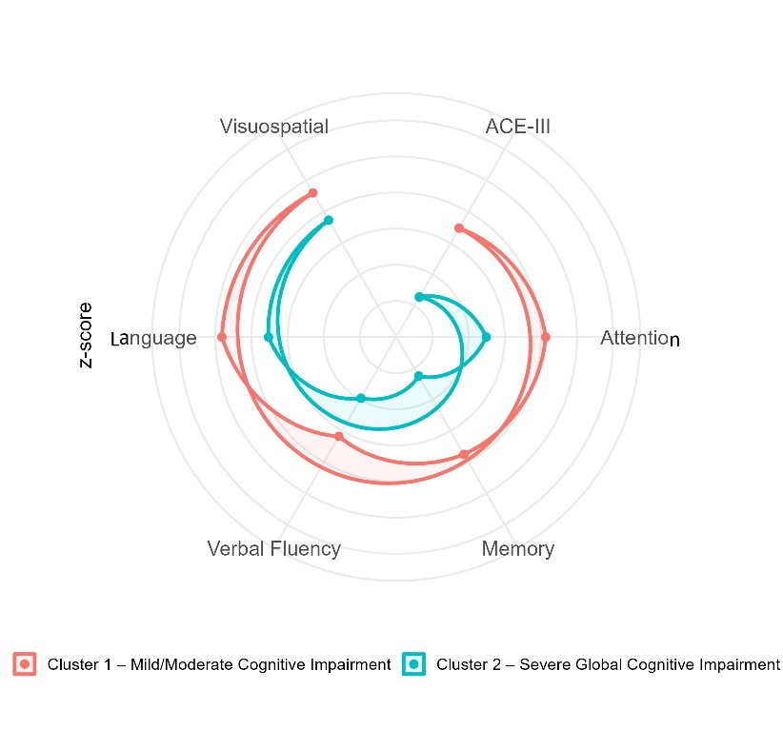

Table 2. Characterization of the two clusters/phenotypes
Variable | Cluster 1 (n=231) | Cluster 2 (n=100) | P | Cohen's d
Demographics
Sex (Male), n (%) | 202 (87.4%) | 72 (72.0%) | .001 | —
Age (Years), M (SD) | 56.39 (8.87) | 57.74 (9.66) | .234 | -0.15
Education (Years), M (SD) | 10.47 (3.57) | 9.58 (4.44) | .079 | 0.23
Neurocognition (ACE-III)
Total ACE-III Score, M (SD) | -1.52 (1.12) | -3.72 (1.45) | <.001 | 1.83
Attention, M (SD) | -0.87 (0.95) | -2.51 (1.81) | <.001 | 1.25
Memory, M (SD) | -1.25 (1.18) | -3.76 (1.52) | <.001 | 1.96
Fluency, M (SD) | -1.83 (1.20) | -3.05 (1.65) | <.001 | 0.91
Language, M (SD) | -0.18 (0.55) | -1.47 (1.28) | <.001 | 1.54
Visuospatial, M (SD) | -0.39 (0.62) | -1.26 (1.14) | <.001 | 1.10
Personality (TIPI)
Openness, M (SD) | 5.58 (4.16) | 4.70 (1.62) | .006 | 0.25
Extraversion, M (SD) | 4.63 (1.67) | 4.53 (1.69) | .603 | 0.06
Stability, M (SD) | 3.56 (1.49) | 3.65 (1.56) | .660 | -0.05
Conscientiousness, M (SD) | 5.70 (1.35) | 5.74 (1.20) | .786 | -0.03
Agreeableness, M (SD) | 6.02 (1.21) | 5.95 (1.27) | .659 | 0.05
Emotional status (HADS)
Depression, M (SD) | 3.71 (3.26) | 5.67 (4.46) | <.001 | -0.53
Anxiety, M (SD) | 6.82 (4.21) | 8.06 (4.43) | .016 | -0.29
Sleep (PSQI)
Sleep Quality, M (SD) | 7.42 (4.13) | 8.35 (4.45) | .074 | -0.22
Social Suport Satisfaction (ESS)
Social Support, M (SD) | 72.87 (11.0) | 71.86 (10.9) | .444 | 0.09
Note. Welch’s t-test was used for continuous variables to account for unequal variances and sample sizes (df adjusted). Chi-square test used for Gender. Significant values (p < .05) are in bold.

Figure 2. ROC curves generated by the seven models

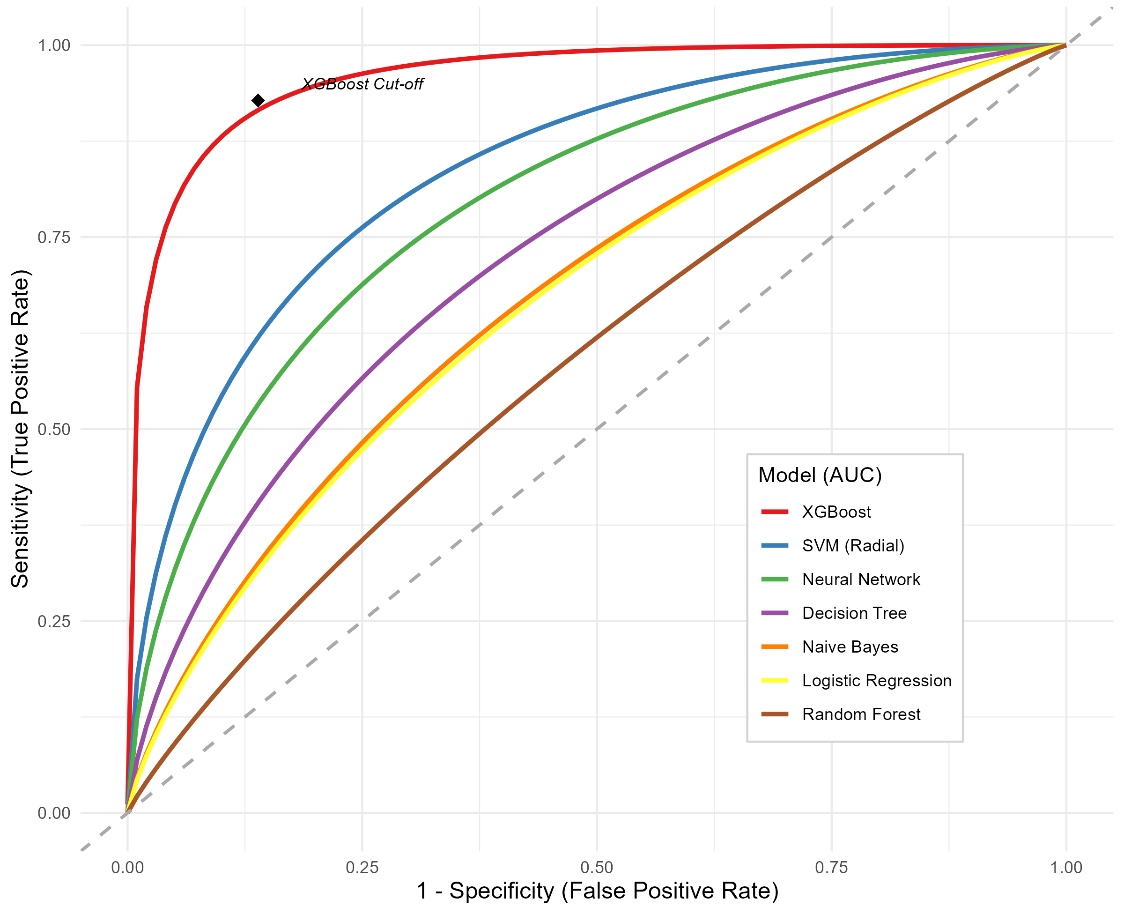

Note: Multi-model ROC curve comparison for predicting severe neurocognitive impairment. The XGBoost model (AUC = .959) significantly outperformed traditional linear and tree-based architectures. The diamond marker indicates the optimal clinical decision threshold (0.301) for the best-performing model.

Table 3. AUC values of the seven models

Algorithm | AUC-ROC
XGBoost | .959
SVM (Radial) | .837
Neural Network | .795
Decision Tree | .724
Naive Bayes | .672
Logistic Regression | .666
Random Forest | .585

Figure 3. Feature importance of the seven models

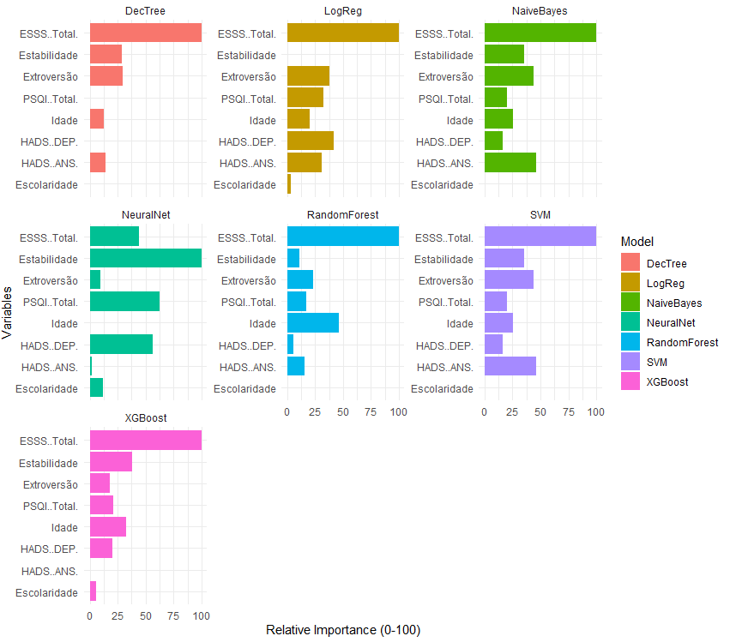

Figure 4. Partial dependence plot on the probability of severe neurocognitive phenotype

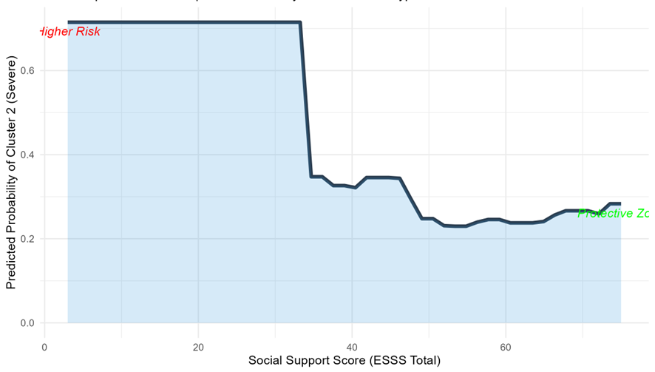

Figure 5. Probability heat map of the interaction between social support and depression

